The Rise of the Ottoman Empire
Objectives | - Improve reading fluency and comprehension through an encyclopedia article.  - Identify the geographical and political circumstances that contributed to the emergence of the Ottoman state.  - Develop an understanding of the Ottoman Empire's origins in northwestern Anatolia.  - Examine maps and historical sources as evidence.  - Distinguish between historical evidence and later myths or interpretations.  - Explain some of the factors that contributed to Ottoman expansion.
Materials  (From Encyclopedia Ottomanica) | - Video: ‘The History of The Ottoman Empire (All Parts)’  -Watch until 11.50 minutes https://www.ottomanica.org/media/videos  - Quiz: https://www.flexiquiz.com/SC/N/16a09adb-73f0-4ad3-a936-3bc543d9f017  - Map of late 14th century Anatolia and surrounding principalities (below)
Essential Questions | - Who were the Ottomans?  - How did a small frontier principality become a major empire?  - Why was geography important to the rise of the Ottoman state?  - What can contemporary sources tell us about how the Ottomans understood themselves?  - How might our understanding of the Ottoman Empire differ from common modern stereotypes?
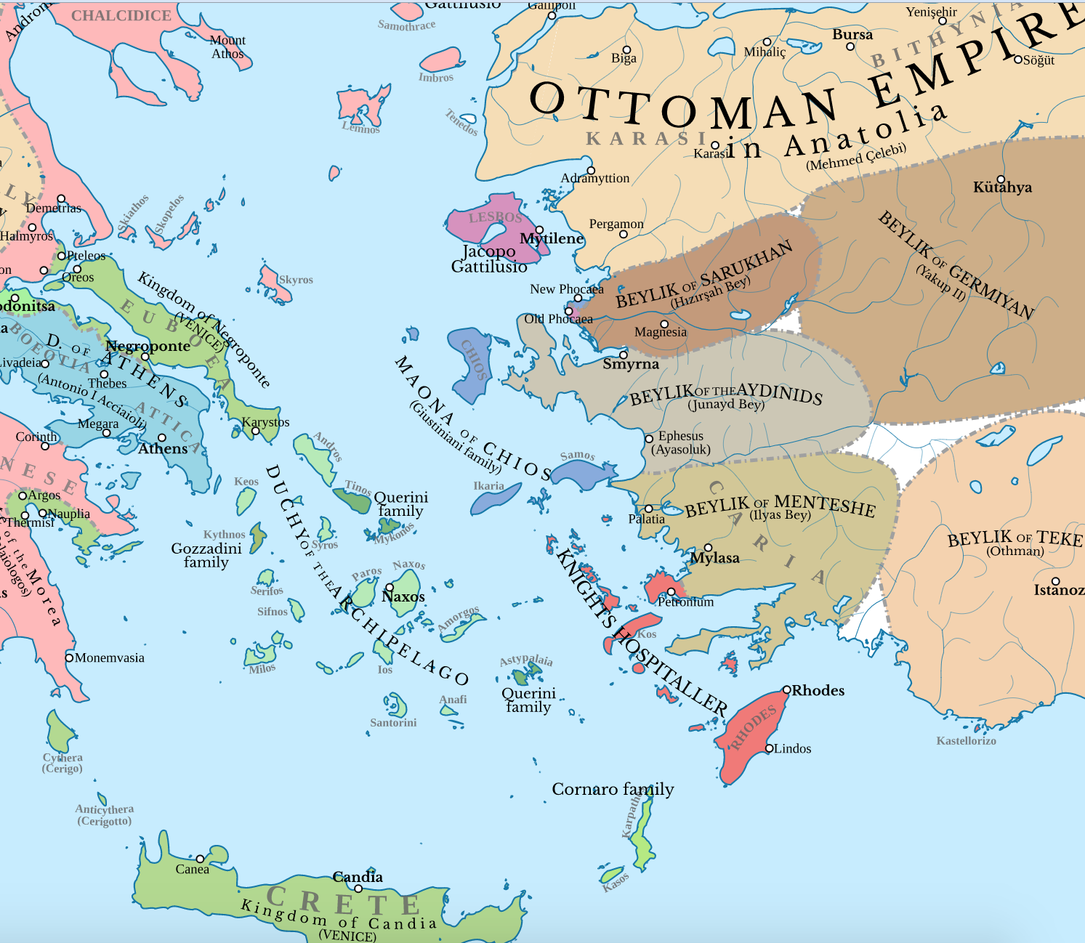
Map of late 14th-century Anatolia and surrounding principalities
Attribution: commons.wikimedia.org/wiki/User:Cplakidas, CC BY-SA 4.0 <https://creativecommons.org/licenses/by-sa/4.0>, via Wikimedia Commons

Instructions

Part One: What Do We Know About the Ottomans?
Ask students:
1. What do you already know about the Ottoman Empire?
Write their answers on the board without immediately correcting them.
Students may mention Constantinople/Istanbul, sultans, the Janissaries, the harem, Islam, Suleiman the Magnificent, wars with Europe, or the First World War.
2. Ask students to identify where they obtained their knowledge. For example, school, social media, films etc.
3. How can we tell whether something we know about the past is historically accurate?
Introduce the idea that historians do not simply memorize facts. They examine primary evidence, including written documents, architecture, coins, manuscripts, paintings, archaeological remains, and maps.
Explain that the Ottoman Empire lasted for more than six centuries, meaning that Ottoman history changed considerably over time.
4. Ask if it would make sense to describe an empire that existed for more than 600 years as if it never changed? Why or why not?
Briefly explain that today's lesson will focus on the origins of the Ottoman state, rather than attempting to cover the entire empire.

Part Two: Where Did the Ottoman Empire Begin?
Display a map of Anatolia and southeastern Europe around 1300 CE.
Ask students to locate:
- Anatolia
- Constantinople
- the Balkans
- the Black Sea
- the Aegean Sea
Explain that the Ottoman state emerged in northwestern Anatolia, in a region close to the Byzantine frontier.
Ask students:
- What advantages might this geographical position have provided?
- What challenges might it have created?
- Why might being located near a powerful neighbouring empire create opportunities for expansion?

Introduce Osman I, traditionally regarded as the founder of the Ottoman dynasty.
Emphasise that the early Ottoman state was very different from the enormous empire that students may already associate with the word “Ottoman.”
The early Ottomans were initially a small tribal chieftaincy, on the frontiers of other tribal polities, and were a frontier state, meaning it was politically volatile, as it was sandwiched between hostile polities like the Byzantines and Germiyanids, and was made up of tribal Turks who had to often co-operate with the sedentary peoples around them. It was not a vast empire controlling territory across three continents, as it would become in the 1500s.

Part Three: From Frontier State to Empire
Hand out Worksheet #1. Students should read the assigned encyclopedia material and/or watch the accompanying short video or teacher presentation. As they work, students should identify the different factors that contributed to Ottoman expansion.
Encourage students to consider:
- geography
- military organisation
- alliances
- political divisions among neighbouring states
- relations with Christian and Muslim communities
- control of strategic territory
Allow students approximately 10–15 minutes to complete the worksheet individually. Students should then work in pairs for 3–5 minutes to compare their answers.
Ask students: Which factor do you think was most important to Ottoman expansion?
Students should support their answer with evidence from the material.

Part Four: Looking at Historical Evidence
Display an image of an early Ottoman artefact, such as a coin, artefact, architectural monument, manuscript illustration or map. Ask students to examine the object before explaining what it is.
Use the following questions:
- What can you see?
- What do you think this object was used for?
- Who might have produced it?
- What does it tell us about the Ottoman state?
- What cannot we determine from this source?
- What additional evidence would a historian need?
Explain that historical sources do not automatically provide complete answers. Historians must interpret them in context and compare them with other evidence.

Worksheet 1: The Rise of the Ottoman Empire

Read the assigned material and answer the following questions.

(Note for teachers: Answers are located at the end of the lesson plan document)

1. Where did the Ottoman state emerge?

2. Who was Osman I?

3. What was the Byzantine Empire?

4. What was a frontier polity?

5.Why was the Ottoman geographical position significant?

6.What factors contributed to Ottoman expansion?

7.What does the early Ottoman state tell us about how empires develop?

Further Activities
The following activities can be used for homework, an additional lesson, or a longer assignment.

1. Timeline Challenge
Give groups a timeline only with key dates from the fourteenth century.
Give them a set of cards with events such as:
- Osman establishes his beylik
- Bursa captured
- İznik captured
- Gallipoli captured
- Edirne captured
- Orhan becomes Sultan
- Battle of Nicopolis
Have them put the cards on the right date. A timeline with dates and key events can be found on Encyclopedia Ottomanica (https://www.ottomanica.org/encyclopedia/timeline/1300-1400/timeline-5)

2. 5. “Who Am I?” Ottoman History
Put a historical figure/event on each student's back without letting them see it.

Examples:
People: Osman I ; Orhan; Murad I; Bayezid I; Despina Hatun; Timur
Events : Battle of Kosovo ; Battle of Nicopolis ; Capture of Bursa ; Capture of Edirne; Battle of Ankara
Students walk around asking questions that can only be answered yes/no.
Examples: “Was I a sultan?” ; “Did I fight the Ottomans?”; “Did this Battle take place in Serbia?”

Answer Key: Worksheet 1

1. Where did the Ottoman state emerge?
The Ottoman state emerged in northwestern Anatolia, close to the frontier of the Byzantine Empire.

2. Who was Osman I?
Osman I was the founder of the Ottoman dynasty and the ruler traditionally associated with the establishment of the Ottoman state.

3. What was the Byzantine Empire?
The Byzantine Empire was the eastern continuation of the Roman Empire. By the late thirteenth and early fourteenth centuries, it had lost much of its former territory but remained an important political power, particularly around Constantinople.

4. What was a frontier polity?
A frontier polity was a political community situated in a border region between larger or competing states. Such regions could experience warfare and political instability, but they could also provide opportunities for expansion.

5. Why was the Ottoman geographical position significant?
The Ottomans were positioned near Byzantine territory and important routes connecting Anatolia and southeastern Europe. Their frontier location provided opportunities for territorial expansion and interaction with neighbouring populations and states.

6. What factors contributed to Ottoman expansion?
Possible answers include:
- effective military organisation
- capable political leadership
- opportunities created by political divisions among neighbouring states
- the strategic geographical position of the early Ottoman state
- alliances and diplomatic relationships
- expansion into Byzantine territories
- control of strategically important locations

7. What does the early Ottoman state tell us about how empires develop?
Empires generally develop through a combination of factors rather than through a single cause. Political circumstances, military power, geography, leadership, diplomacy, economic resources, and relations with neighbouring populations can all contribute to expansion.

